Digital Maketing

Instructor: Dr. Abeer Hassan Ramadan

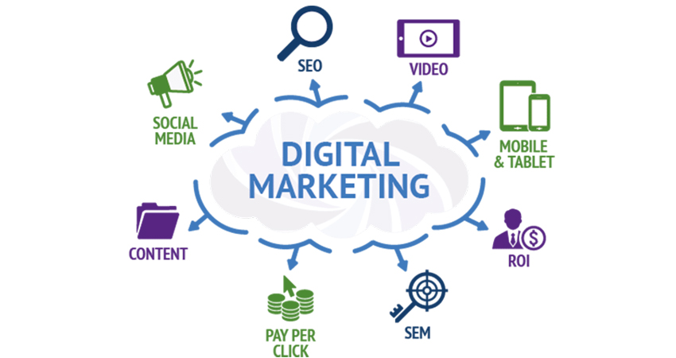

December 11, 2020

Digital marketing

Alexandria, Egypt

Name: Ibrahim Mostafa Ibrahim Elshenhapy  
ID: 4715  
Group (2): Monday 5th Period [3:50 ~ 5:30]

Contents

Abstract 2

Introduction 2

Digital Marketing 3

The Origin of Digital Marketing 4

Evolution of Digital Marketing 5

Types of Digital Marketing Strategies 6

Search Engine Optimization (SEO) 7

Affiliate Marketing 7

Native Advertising 8

Marketing Automation 8

Pay Per Click (PPC) 8

Email Marketing 8

Inbound Marketing 9

Online PR 9

Digital Marketing Strategies 9

Digital Marketing Challenges 10

Hire and build an effective marketing organization 11

Scale data-driven marketing across the organization 11

Create a digital marketing strategy 11

Prove business impact and ROI 12

Integrate the martech stack 12

Secure incremental funding 12

Win with personalization 13

Literature review 13

Conclusion 15

References 16

# Abstract

This report aims at understanding the preferred emerging media options used for marketing. In the Internet age many new methods used for product promotion and marketing. "Desk research" has been turned into "online research", now in the online, market research has become possible. Many companies are using digital marketing for competitive advantage. Social Media has quickly gained prominence as it provides people with the opportunity to communicate and share posts and topics. The development of information technology, followed by the advancement of digital communication tools, has encouraged businesses to change the way of communicating the product. Digital Marketing communications strategy is a strategy of using digital communication media. The purpose of the undertaken study is to examine the effectiveness of online digital media advertising and about emerging media options used for marketing.

# Introduction

Digital marketing is the use of the Internet, mobile devices, social media, search engines, and other channels to reach consumers. Some marketing experts consider digital marketing to be an entirely new endeavour that requires a new way of approaching customers and new ways of understanding how customers behave compared to traditional marketing. Digital marketing's development since the 1990s and 2000s has changed the way brands and businesses use technology for marketing. As digital platforms are increasingly incorporated into marketing plans and everyday life, and as people use digital devices instead of visiting physical shops, digital marketing campaigns are becoming more prevalent and efficient.

Digital marketing poses special challenges for its purveyors. Digital channels are proliferating rapidly, and digital marketers have to keep up with how these channels work, how they're used by receivers, and how to use these channels to effectively market their products or services. In addition, it is becoming more difficult to capture receivers' attention, because receivers are increasingly inundated with competing ads.

Digital marketers also find it challenging to analyse the vast troves of data they capture and then exploit this information in new marketing efforts.

The challenge of capturing and using data effectively highlights that digital marketing requires an approach to marketing based on a deep understanding of consumer behaviour. For example, it may require a company to analyse new forms of consumer behaviour, such as using website heat maps to learn more about the customer journey.

# Digital Marketing

In a world where over 170 million people use social media on a regular basis, every working professional is expected to be familiar with at least the core tenets of [Digital Marketing](https://www.simplilearn.com/digital-marketing/). In simple terms, Digital Marketing is the promotion of products over the internet or any form of electronic media. According to the Digital Marketing Institute, "Digital Marketing is the use of digital channels to promote or market products and services to targeted consumers and businesses." People are consuming digital content on a daily basis. Very soon, traditional marketing platforms will disappear, and the digital market will completely take over. There are a number of [advantages in Digital Marketing](https://www.quora.com/What-are-the-advantages-of-Digital-Marketing). Unlike traditional marketing, digital marketing is more affordable. You can reach a larger audience in a shorter time period. Technological advances have resulted in considerable attrition of the customer-base of traditional marketing agencies and

departments. People have moved on to tablets, phones, and computers, which are the areas where digital marketers have gained the most ground.

## The Origin of Digital Marketing

The term Digital Marketing was first used in the 1990s. The digital age took off with the coming of the internet and the development of the Web 1.0 platform. The Web 1.0 platform allowed users to find the information they wanted but did not allow them to share this information over the web. Up until then, marketers worldwide were still unsure of the digital platform. They were not sure if their strategies would work since the internet had not yet seen widespread deployment. In 1993, the first clickable banner went live, after which HotWired purchased a few banner ads for their advertising. This marked the beginning of the transition to the digital era of marketing. Because of this gradual shift, the year 1994 saw new technologies enter the digital marketplace. The very same year, [Yahoo](https://www.yahoo.com/) was launched. Also known as "Jerry's Guide to the World Wide Web" after its founder Jerry Yang, Yahoo received close to 1 million hits within the first year. This prompted wholesale changes in the digital marketing space, with companies [optimizing their websites](https://www.simplilearn.com/digital-marketing/search-engine-optimization-seo-certification-training) to pull in higher search engine rankings. 1996 saw the launch of a couple of more search engines and tools like HotBot, LookSmart, and Alexa. 1998 saw the birth of [Google](https://www.google.com/). Microsoft launched the MSN search engine and Yahoo brought to the market Yahoo web search. Two years later, the internet bubble burst and all the smaller search engines were either left behind or wiped out leaving more space for the giants in the business.

## Evolution of Digital Marketing

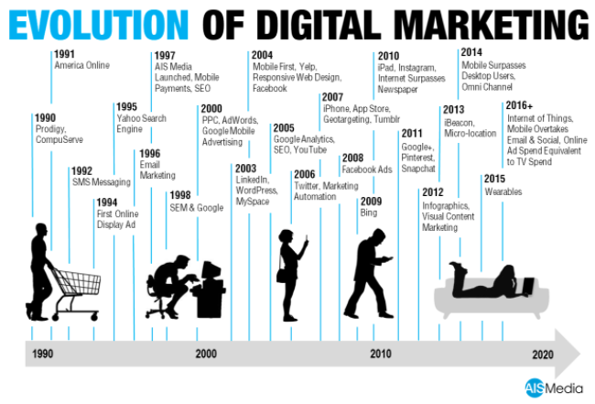In the 2000s, with increasing numbers of Internet users and the birth of [iPhone](https://en.wikipedia.org/wiki/IPhone), customers began searching products and making decisions about their needs online first, instead of consulting a salesperson, which created a new problem for the marketing department of a company. In addition, a survey in 2000 in the United Kingdom found that most retailers had not registered their own domain address. These problems encouraged marketers to find new ways to integrate digital technology into market development. The digital marketing world saw its first steep surge in 2006 when search engine traffic was reported to have grown to about 6.4 billion in a single month. Not one to get left behind, Microsoft put MSN on the backburner and launched Live Search to compete with Google and Yahoo. Then came Web 2.0, where people became more active participants rather than remain passive users. Web 2.0 allowed users to interact with other users and businesses. Labels like ‘super information highway’ began to be applied to the internet. As a result, information flow volumes –including channels

utilized by digital marketers- increased manifold, and by 2004, internet advertising and marketing in the US alone brought in around $2.9 billion.

## Types of Digital Marketing Strategies

Digital marketers are in charge of driving brand awareness and lead generation through all the digital channels both free and paid at company's disposal. These channels include social media, the company's own website, search engine rankings, email, display advertising, and the company's blog. The digital marketer focuses on different key performance indicator (KPI) for each channel so they can properly measure the company's performance across each one. Digital marketing is carried out across many marketing roles today. In small companies, one generalist might own many of the digital marketing tactics described above at the same time. In larger companies, these tactics have multiple specialists that each focus on just one or two of the brand's digital channels. Here are some examples of these specialists: The best digital marketers have clear picture of how each digital marketing campaign supports their overarching goals. And depending on goals of their marketing strategy, marketers can support larger campaign through free and paid channels at their disposal. A content marketer, for example, can create series of blog posts that serve to generate leads from a new eBook the business recently created. The company's social media marketer might then help promote these blog posts through paid and organic posts on the business's social media accounts. Perhaps the email marketer creates an email campaign to send those who download the eBook more information on company. Following are some of most common digital marketing tactics and the channels involved.

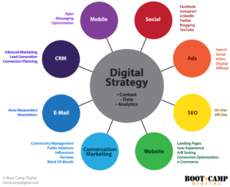Search Engine Optimization (SEO)

This is process of optimizing website to "rank" higher in search engine results pages, thereby increasing the amount of organic traffic your website receives. The channels that benefit from SEO include Websites, Blogs, and Info graphics.

Social Media Marketing

This practice promotes your brand and your content on social media channels to increase brand awareness, drive traffic, and generate leads for your business. The channels you can use in social media marketing include Face book, Twitter, LinkedIn, Instagram, Snap chat, Pinterest, and Google+.

Content Marketing

It denotes the creation and promotion of content assets for the purpose of generating brand awareness, traffic growth, lead generation, and customers. The channels that can play a part in your content marketing strategy include Blog posts, EBooks and whitepapers, Info graphics, Online brochures and look books.

### Affiliate Marketing

This is a type of performance based advertising where you receive commission for promoting someone else's products, services on your website. Affiliate marketing channels include Hosting video ads through the YouTube Partner Program and Posting affiliate links from your social media accounts.

### Native Advertising

Native advertising refers to advertisements that are primarily content-led and featured on a platform alongside other, non-paid content. Buzz Feed-sponsored posts are a good example, but many people also consider social media advertising to be "native" – Face book advertising and Instagram advertising.

### Marketing Automation

Marketing automation refers to the software that serves to automate your basic marketing operations. Many marketing departments can automate repetitive tasks they would otherwise do manually, such as Email newsletters, Social media post scheduling, Contact list updating, Lead-nurturing workflows, Campaign tracking and reporting.

### Pay Per Click (PPC)

This PPC is a method of driving traffic to your website by paying a publisher every time your ad is clicked. One of the most common types of PPC is Google Ad Words, which allows you to pay for top slots on Google's search engine results pages at a price "per click" of the links you place. Other channels where you can use PPC mainly include Paid ads on Face book, Promoted Tweets on Twitter, Sponsored Messages on LinkedIn.

### Email Marketing

Companies use email marketing as a way of communicating with their audiences. Email is often used to promote content, discounts and events, as well as to direct people toward the business's website. The types of emails you might send in an email marketing campaign include Blog subscription newsletters, Follow-up emails to website visitors who downloaded something, Customer welcome emails, Holiday promotions to loyalty program members, Tips or similar series emails for customer nurturing.

### Inbound Marketing

Inbound marketing refers to the "full-funnel" approach to attracting, engaging, and delighting customers using online content. You can use every digital marketing tactic listed above throughout an inbound marketing strategy.

### Online PR

Online PR is practice of securing earned online coverage with digital publications, blogs, an other content-based websites. It's much like traditional PR, but in the online space. The channels you can use to maximize your PR efforts include: Reporter outreach via social media Engaging online reviews of your company, Engaging comments on your personal website or blog.

## Digital Marketing Strategies

An effective digital strategy will help you take the right decisions to make a company successful online.  A strategy process model provides a framework that gives a logical sequence to follow to ensure inclusion of all key activities of strategy development and implementation. Like using the SOSTAC planning approach. Which is Digital Marketing Strategy should involve a review to check that all of your capabilities are in place to help your organization manage all of the digital touchpoints.

* **Plan** - Use a data-driven approach to review your current digital marketing effectiveness, customize analytics, set up KPI dashboards and SMART objectives create a strategy of prioritized improvements to how you deploy digital marketing media, technology and data to increase leads and sales
* **Reach -**Build awareness using the 6 key online marketing techniques which will drive visits to your site.
* **Act** - Encourage interactions on your website or social media to help you generate leads for future
* **Convert** - Use retargeting, nurturing and conversion rate optimization to remind and persuade your audience to buy online or offline if phone and face-to-face channels if these are important to you.
* **Engage** - Increase sales from existing customers by improving personalized communications using web, email and social media marketing.

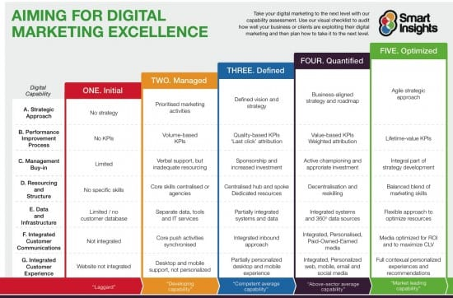

## Digital Marketing Challenges

Digital marketing has become a powerful growth driver; it interacts with every aspect of the business, drives gains at both ends of the sales funnel and provides undeniable

business value. However, new technologies and tactics vary in use and impact, creating new challenges for modern marketing and sales leaders.

### [Hire and build an effective marketing organization](https://www.prophet.com/guide/digital-marketing/challenges/)

55% of marketers find hiring people with the right skills the top challenge for their organization, highlighting how difficult it is to hire and organize an effective team in today's environment. To overcome this challenge, you must define the work to be done and arrange the right combination of new hires, team upskilling and use of agency partners. Teams also need new governance, teaming and tools that enable them to work together in an agile and customer-centric way, breaking away silos. The approach must be comprehensive and pragmatic, covering the body, mind and soul of the marketing and sales organization, to deliver superior outcomes.

### [[Scale data-driven marketing across the organization](https://www.prophet.com/guide/digital-marketing/challenges/)](https://www.prophet.com/guide/digital-marketing/challenges/)

While businesses are often able to implement digital marketing practices within a single business unit, channel or use case, the reality is that 54% of marketers find that scaling innovation across the organization is one of their top challenges. Design, piloting and scaling digital marketing that moves the needle is crucial. The added challenge is doing so while growing technical capabilities, embedding new skills and creating new behaviors across the organization. Companies need the right experts, best practices, training in agile methods and digital playbooks to meet their objectives and deliver higher marketing ROI.

### [[Create a digital marketing strategy](https://www.prophet.com/guide/digital-marketing/challenges/)](https://www.prophet.com/guide/digital-marketing/challenges/)

With multiple competing priorities, pressure to deliver short-term results, and rapidly changing technology, marketers struggle to develop a clear strategy for what digital marketing must accomplish and how it will function across the business. Leaders need a digital marketing strategy based on category dynamics and the requirements of their

business. Effective strategy demands targeting customer opportunities, assessing capabilities, prioritizing gaps and establishing the roadmap to turn customer insight into growth. The path to effective digital marketing requires assembling the right experts, using best practices and immersive collaboration to gain buy-in for the strategy across teams, functions and geographies.

### [[Prove business impact and ROI](https://www.prophet.com/guide/digital-marketing/challenges/)](https://www.prophet.com/guide/digital-marketing/challenges/)

Digital tools have made it easier for marketers to attribute business impact to their marketing actions but that's only a part of the challenge.Marketing and sales leaders struggle to demonstrate how analytics and insights deliver meaningful business impact across their different growth levers. They must harness data from multiple digital sources to create measurement systems that can scale across the organization and provide both qualitative and quantitative insights to prove the value of digital marketing.

### [[Integrate the martech stack](https://www.prophet.com/guide/digital-marketing/challenges/)](https://www.prophet.com/guide/digital-marketing/challenges/)

Purchasing or integrating the right software is one of the top challenges for 46% of the growth leaders surveyed in the study. Decision makers must contend with over 7,000 different market vendors and integrate people and processes and technology platforms to unlock the potential of data and tools to improve performance. Building and improving the market stack takes defining requirements and a blueprint to operationalize data-driven marketing across use cases (e.g., lead generation). Finding technology agnostic advisors who can guide platform evaluation and make recommendations for feature upgrades, integrations and technology purchases is a common need.

### [[Secure incremental funding](https://www.prophet.com/guide/digital-marketing/challenges/)](https://www.prophet.com/guide/digital-marketing/challenges/)

Although marketers are being asked to take on more and more every year, their budgets remain stagnant. 46% of marketers said getting increased investment or support from

leadership continues to be a top challenge. It demands identifying decision makers, influencers and contributors, understanding their needs and creating powerful narratives to make the case for and secure incremental investment. Partnering with industry leading researchers and digital experts can help make the case through a combination of industry analogs, data and in-depth knowledge of what truly moves the needle.

### [[Win with personalization](https://www.prophet.com/guide/digital-marketing/challenges/)](https://www.prophet.com/guide/digital-marketing/challenges/)

While today's customers demand to be recognized across their digital interactions and expect a cohesive, positive experience at every digital touchpoint, only 33% of survey participants consider creating and delivering personalized content their top challenge. It's a matter of their digital maturity not importance. Many don't realize that tailoring content, customizing for user profiles and true personalization has become more achievable because of new data sources and marketch tools. Personalization schemes based on multi-factor customer segments, can be deployed in B2B and B2B2C with pragmatic guidance.

# Literature review

**Journal of Digital & Social Media Marketing** is the major peer-reviewed, professional journal for all those involved in the marketing of products or services using digital channels. Its overriding goal is to provide an authoritative, practitioner-focused forum to support the professional development of all those working in, or entering, the field. As such, the Journal’s content is both of direct relevance to the practice of digital marketing and intellectually rigorous.

* **The anatomy of an effective e-mail subject line: How to stand out in a crowded inbox**. *Ewelina Aiossa, Founder, B.I.G. Marketing Consulting*

E-mail marketing is one of the most pervasive communication tools around and its importance continues to grow with the use of technology. It is also one of the best and most cost-efficient ways to get a message out to a specific audience. However, professional and personal e-mail inboxes are crowded with messages, and brands/companies need to compete to be noticed. For their messages to break through the noise of the crowded inbox, marketers must start with the subject line. Drafting the perfect subject line is an art form with a little bit of science thrown in. It requires an intimate knowledge of one’s target audience and the ability to translate a larger message into a few words to strike the right chord and compel the recipient to take action. This paper explores how to provide the most relevant, personalised e-mail subject line ‘experience’ by discussing the fundamentals of how to draft compelling, effective subject lines.

* **Social media: The impact of advertising, endorsements and trust among consumers**. *Russell Feldman, Head of Digital, Media & Technology and Michael Stacey, Marketing Insights Director, YouGov*

Perception on social media is paramount. For this reason, many regular users have developed a tolerance for inaccuracy or dishonesty. Indeed, there is a basic expectation that a person’s online persona will differ from how they present offline. This also is the case for many brands. Advertising and celebrity endorsements are rife on social media, and most users recall seeing such communications on a regular basis. From Twitter, to Facebook, to Twitch, social media networks are here to stay and have attracted many different demographics, resulting in greater opportunities for brands to communicate their wares to all manner of consumers. Brands have plenty of opportunities to find their voice but even when they approach authenticity, users may still doubt their motivations. This paper reports on in-depth research conducted by YouGov to ascertain

consumer perceptions towards social media networks, advertisements and celebrity endorsements, and the opportunities (and pitfalls) that brands face.

* **Increasing in-store sales through creative omni-channel digital and social media marketing strategies: Case study of HobbyTown** *Andrew Smith, President, initiate-it.*

Many retailers with brick-and-mortar locations are losing ground or failing due to the rapid rise of e-commerce. In stark contrast, US toys and games retailer HobbyTown saw 5 consecutive quarters of increased in-store sales and customer engagement following 12 consecutive quarters of declining sales. This dramatic reversal resulted from successful, strategic digital and social media marketing campaigns featuring strategies that revitalised the social, web and mobile channels through which HobbyTown connected and interacted with current and potential customers. HobbyTown understood the unique value of the immersive in-store experience offered to customers and capitalised on this knowledge by using highly personalised and localised digital marketing techniques to increase purchases within physical store locations. This paper explores the methodology of these digital and social media marketing strategies, including campaign development, implementation, measurement and results. The insights shared will enable retailers with physical store locations to develop effective digital and social media strategies to deploy when social distancing directives for COVID-19 are fully lifted and business returns to normal.

# Conclusion

Digital marketing allows marketers to see accurate results in real time. If an advert is put in newspaper, it is difficult to estimate how many people actually flipped to that page and paid attention to ad. There's no surefire way to know if that ad was responsible

for any sales at all. Yet digital marketing would help you to know reach for your product/service, to get engaged with prospective customers, to have global reach, to promote in personalized manner. However, with digital marketing have some setbacks .Digital marketing is highly dependent on the internet. Because internet may not be accessible in certain areas or consumers may have poor internet connection. It has lot of clutter, so marketers find it hard to make their advertisements stand out, and get consumers to start conversations about an organizations brand image or products. But still large amount of competing goods and services that are also using same digital marketing strategies can be the disadvantage. Some companies can be portrayed by customers negatively as some consumers lack trust online due to the amount of advertising that appears on websites and social media that can be considered frauds. Even an individual or small group of people can harm image of an established brand. Digital marketing disseminates only information to prospects most of whom do not have purchasing authority/power. Hence reflection of digital marketing into real sales volume is skeptical.

To summarize, digital marketing has a bright future for long term sustainability of the product or services in the current technological market with all its pros and cons.

# References

* Kannan, P.K.; Li, Hongshuang “Alice” (March 2017). "Digital marketing: A framework, review and research agenda". International Journal of Research in Marketing.
* henrystewartpublications.com (journal of digital marketing)
* simplilearn.com: history and evolution of digital marketing article
* acq-intl.com: how to implement a flawless digital marketing strategy
* ["The Four Faces of Digital Marketing"](https://www.ama.org/marketing-news/the-four-faces-of-digital-marketing/). *American Marketing Association*
* Hart, Cathy; Doherty, Neil; Ellis‐Chadwick, Fiona (2000-09-01). "Retailer adoption of the Internet – Implications for retail marketing". European Journal of Marketing.
* [ignitevisibility.com: what is digital](https://ignitevisibility.com/what-is-digital) marketing
* smartinsights.com: digital marketing strategy
* prophet.com: guide digital marketing challenges
* Ryan, D. (2014). Understanding Digital Marketing: Marketing Strategies for Engaging the Digital Generation Ed.
* McCarthy, E. J. (1964), Basic Marketing, Richard D. Irwin, Homewood, IL.